Introduction to R

Data & Software Carpentry, with edits and reorganization by the Montana State University R Workshops Team

The term R is used to refer to both the programming language as well as the software that interprets the scripts written using it. The learning curve may be steeper than with other statistical software, but with R the results of your analysis or your plot does not rely on remembering what order you clicked on things, but instead on the written commands you generated. In R you will work in scripts or with dynamic documents, with scripts within them (Rmd or Rnw files). Scripts may feel strange at first, but they make the steps you used in your analysis clear for both you and for someone who wants to give you feedback, further promoting the importance of reproducible science!

RStudio is a free computer application that allows you access to the resources of R, while providing you with a comfortable working environment. There are many ways you can interact with R, but for many reasons RStudio has become the most popular. To function correctly, RStudio uses R behind the scenes, hence both need to be installed on your computer. Both R and RStudio are cross-platform, so that everyone’s versions look and operate the same regardless of their operating system!

For this workshop, we will be making use of the RStudio that you will need to install on your computer or a virtual desktop machine (available to MSU affiliated participants). For more details on this, you have hopefully completed the steps discussed here <https://greenwood-stat.shinyapps.io/InstallDemo_RWorkshops/>. The short version for downloading is to first go to <https://cloud.r-project.org/> to R installed and then go to <https://rstudio.com/products/rstudio/download/> to install RStudio.

If you did not complete that or do not have a computer available, you can You can also borrow a laptop from the MSU library (or maybe from a good friend) for the workshop. It needs to be a computer that is running Linux, Windows, or a somewhat recent macOS. Unfortunately, a chromebook or ipad are not sufficient for installing and running R.

However you get to it, RStudio has four possible panels, where each can be viewed at the same time and has multiple tabs available.

* the **Editor** for your scripts and documents (top-left)
* the R **Console** (bottom-left)
* your **Environment (Objects/Variables)/History** (top-right)
* and your **Files/Plots/Packages/Help/Viewer** (bottom-right).

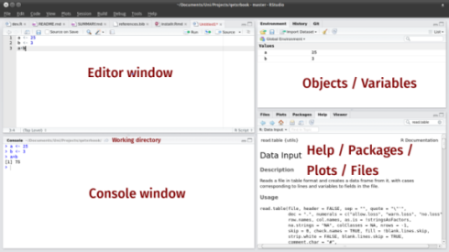

RStudio layout

## Working in R

The document we provided for you is an Rmarkdown (.Rmd) document. It allows you to work in a reproducible fashion, with both code (placed in what are called code chunks) and descriptions of results in the same file. The grey sections that have three single quotes then {r} will delineate a code chunk.

```{r}  
1 + 1  
```

You can add these with Insert -> R into a .Rmd file. Type all of your code in these code chunks and other documentation and interpretation of results outside of the code chunks (like we are doing here). Although there are more complex ways to work in RStudio, you should start today with saving this .Rmd file into a folder that also contains any data and other figures you might want to read into this document. When you do that, RStudio will know where to look to read in the data so you do not need to know the path for its physical location on your computer. Once we are done with our local work, we can also use the Knit button to compile our work into HTML, Word (DOCX), or PDF documents. We will demonstrate this at the end of the workshop - but this will only work if all the code “runs” and what we have provided you has some errors in it. One other great (and fairly new) feature in these files is that it does live spell-checknig - I mean spell-checking - by underlining suspect words. We will also discuss RStudio “Projects” that take this one step further in terms of organizing your work built around this markdown framework. It is important to understand the various ways to do your work in R using RStudio.

RStudio allows for you to execute commands directly from the code chunk in the document by using the **Ctrl + Enter** (on Macs, **Cmd + Return**) shortcut. If you place your cursor on the line in the code chunk that you would like to run and hit this shortcut, R will execute that line(s) of code for you. Alternatively, you can also execute code in the console (where the output of the commands pops up). The difference between running code in the console and in the document is that any code you execute in the console will be lost once you close your R session. If you type code into the document’s code chunks, it will be saved when you close your R session. Because we want to be able to go back and re-run our code after today’s workshop, it is better to type the command we want R to run in the document and save it!

If R is ready to accept commands, the R console (in the bottom-left) will show a > prompt. When R receives a command (by typing, copy-pasting, or using the shortcut), it will execute it, and when finished will display the results and show the > symbol once again. If R is still waiting for you to provide it with additional instructions, a + will appear in the console. This should tell you that you didn’t finish your command. You could have forgotten to close your parenthesis or a quotation. If this happens and you are unsure of what went wrong, click inside the console and hit the Esc key. Then you can start over and figure out where you went wrong!

### Calculator

**Practice**: Enter each of the following commands and confirm that the response is the correct answer. Try to do this in the console and by executing the code in the code chunk, both line by line and all at once.

1 + 2

## [1] 3

16*9

## [1] 144

sqrt(2)

## [1] 1.414214

20/5

## [1] 4

18.5 - 7.21

## [1] 11.29

## Creating Objects

These operations, however, are not very interesting. To do more useful things in R, we need to assign values to an object. To create an object, we tell R the object’s name, followed by an assignment arrow (<-), and finally the value of the object. This would look something like this:

x <- 6

Once we execute/run this line of code, we notice that a new object appears in our environment window. This window shows all of the objects that you have created during your R session. The value of x appears next to it, since it is a scalar.

**Remarks:**

* In the above code <- is the assignment operator. It assigns values on the right to objects on the left. So, after executing year <- 6, the value of year is 6. The arrow can be read as 6 goes into year. For historical reasons, you can also use = for assignments, but not in every context. Because of the slight differences in syntax, it is best practice to always use <- for assignments.
  + In RStudio, typing Alt at the same time as the - key will write <- in a single keystroke. Neat! (Option + - on MacOS)
* There are a few simple rules that apply when creating the same of a new object (like we did above):
  + R is case sensitive, so if you name your variable cat but then try to run the code Cat + 2, you will get an error saying that Cat does not exist
  + You also want your object’s name to be explanatory, but not too long. Think current_temperature verses current_temp. Do you really want to type out temperature every time?
  + Finally, you cannot begin any object’s name with a number. You can end a name with a number (e.g. clean_data2), but does that give you much information about what is in the contents of clean_data2 relative to clean_data?
  + The name cannot contain any punctuation symbols, except for . and _ (. is not recommended)
  + You should not name your object the same as any common functions you may use (mean, sd, etc.)
* Using a consistent coding style makes your code clearer to read for your future self and your collaborators.

### Clean Code

Yes, writing code may be completely new to you, but there is a difference between code that looks nice and code that does not. Generally, object names should be nouns and function names should be verbs. It is also important that your code looks presentable, so that a friend/college/professor can read it and understand what you are doing. For these reasons, there are style guides for writing code in R. The two main style guides are Google’s and the slightly more comprehensive Tidyverse style guide . Optionally, you can install lintr to automatically check and correct for issues in your code styling. More on packages to come!

## Working with Objects

When you assign a value to an object (like we did previously) R does not output anything by default. If you enclose the code you wrote in parenthesis, then R will output the value of the object you created.

x <- 6  
  
(x <- 6)

## [1] 6

Once the object has been created, you can use it! Run the following lines of code:

2.2 * x

## [1] 13.2

4 + x

## [1] 10

We can also overwrite an object’s value, so that it has a new value. In the code below create a new object y and then we give x a new value of 2.

y <- x + 6  
  
x <- 2

**Exercise 1:** What is the current value of y? 12 or 8?

# Exercise 1 code here!  
  
y

## [1] 12

## Working with Different Data Types

A vector is the basic data type in R. A vector is a series of values, which can be either numbers or characters, but every entry of the vector must be the same data type. R can tell that you are building a vector when you use the c() function, which concatenates a series of entries together.

temps <- c(50, 55, 60, 65)  
temps

## [1] 50 55 60 65

To make a vector of characters, you are required to use quotation marks (" ") to indicate to R that the value you are using is not an object you already created in R.

animals <- c("cat", "dog", "bird", "fish")  
animals

## [1] "cat" "dog" "bird" "fish"

Important features of a vector is the type of data they store. Run the following lines of code and decide what type of data the vectors contain.

class(temps)

## [1] "numeric"

class(animals)

## [1] "character"

**Exercise 2:** Create a vector, named dec, that contains decimal valued numbers. Then check what data type does that vector contain?

# Exercise 2 code here!  
  
dec <- c(1,2,3.4)  
dec

## [1] 1.0 2.0 3.4

class(dec)

## [1] "numeric"

Another possible data type is a logical (Boolean) value. This type of data  
takes on values of TRUE and FALSE. But, we said that vectors could only be numbers or characters. If TRUE and FALSE don’t have quotations around them, then they aren’t characters. So, then they must be numbers. What numbers do you think they are?

logic <- c(TRUE, FALSE, FALSE, TRUE)  
  
class(logic)

## [1] "logical"

**Exercise 3:** What happens when we try to mix different data types into one vector? Speculate what will happen when we run each of the following lines of code:

num_char <- c(1, 2, 3, "a")  
  
num_logic <- c(1, 2, 3, FALSE)  
  
char_logic <- c("a", "b", "c", TRUE)  
  
guess <- c(1, 2, 3, "4")

In each of these vectors, the two types of data were *coerced* into a single data type. This happens in a hierarchy, where some data types get preference over others. Can we draw a diagram of the hierarchy?

## Lists

While the elements of vectors have to be of the same data type, a list is a special vector in R that allows for you to store a variety of types of objects. If you have a vector, a matrix, and/or a character, you can store all of them into one list object!

The arguments to the list function are the components of the list, where the components can be characters, vectors, matrices, or other data structures. Here, we create a list whose components are the three vectors we’ve been working with:

my_first_list <- list(animals, temps, logic)  
my_first_list

## [[1]]  
## [1] "cat" "dog" "bird" "fish"  
##   
## [[2]]  
## [1] 50 55 60 65  
##   
## [[3]]  
## [1] TRUE FALSE FALSE TRUE

my_first_list[[1]]

## [1] "cat" "dog" "bird" "fish"

We notice that when printing a list, the output looks a bit different. There are a whole bunch of brackets! Let’s break them down. I like to think of a list as a shelf with cubby holes. The cubby holes are the components of the list, but there are elements in each cubby.

* To get to a specific component (cubby) of a list, you use the double brackets next to the name of the list (e.g my_first_list[[1]]).
* To access the elements inside each cubby, you then use single square brackets (e.g. my_first_list[[1]][2]).

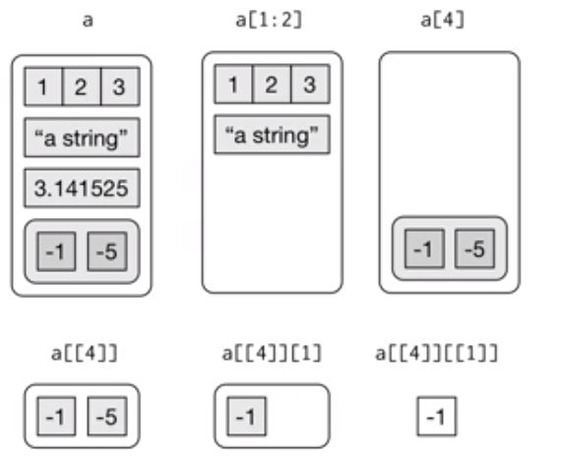

Example of lists

### Named Lists

my_named_list <- list(title = "statistics",   
 numbers = 1:10,  
 data = TRUE)  
my_named_list

## $title  
## [1] "statistics"  
##   
## $numbers  
## [1] 1 2 3 4 5 6 7 8 9 10  
##   
## $data  
## [1] TRUE

We see the output for a named list is slightly different. Instead of double brackets next to each component, there are now $ and names of the variable. This will help you understand the structure of data.frames (coming up next)!

## Importing Data

* Use the **Import Dataset** button in the **Environment** tab
* Choose the **From Text (base)** option
* Click on the **Browse** button
* Direct the computer to where you saved the BlackfootFish.csv data file, click **open**
* It will bring up a preview of the data
* Make sure that the box labeled “Strings as factors” is not checked
* Click on the **Import** button

Notice the code that outputs in the console (the bottom left square). This is the code that you could have typed in the code chunk below to import the data yourself. Copy and paste the code that was output in the code chunk below.

# copy and paste the code that was used by R to import the data   
# be careful to only copy the code that is next to the > signs!   
 BlackfootFish <- read.csv("BlackfootFish.csv")

The path provided can also be simplified to just include the file name - if the .Rmd and data are saved in the same folder. If you have any trouble reading in the data set, here is code that allows you to read the data from our github repository:

BlackfootFish <- read.csv("https://github.com/saramannheimer/data-science-r-workshops/raw/master/Introduction%20to%20R/AY%202020-2021/Student%20Version/BlackfootFish.csv")

## Structure of Data

The data we will use is organized into data tables. When you imported the BlackfootFish data into RStudio it was saved as an object. You are able to inspect the structure of the BlackfootFish object using functions built in to R (no packages necessary).

Run the following code. What is output from each of the following commands?

class(BlackfootFish) ## What is the object class of the data?

## [1] "data.frame"

dim(BlackfootFish) ## What is the first number represent? What about the second number?

## [1] 18352 7

names(BlackfootFish) ## What does this output refer to?

## [1] "trip" "mark" "length" "weight" "year" "section" "species"

str(BlackfootFish) ## What is the structure of the data?

## 'data.frame': 18352 obs. of 7 variables:  
## $ trip : int 1 1 1 1 1 1 1 1 1 1 ...  
## $ mark : int 0 0 0 0 0 0 0 0 0 0 ...  
## $ length : num 288 288 285 322 312 363 269 160 213 157 ...  
## $ weight : num 175 190 245 275 300 380 170 40 80 35 ...  
## $ year : int 1989 1989 1989 1989 1989 1989 1989 1989 1989 1989 ...  
## $ section: chr "Johnsrud" "Johnsrud" "Johnsrud" "Johnsrud" ...  
## $ species: chr "RBT" "RBT" "RBT" "RBT" ...

summary(BlackfootFish) ## What is the data type of each variable in our dataset?

## trip mark length weight   
## Min. :1.000 Min. :0.00000 Min. : 16.0 Min. : 0.0   
## 1st Qu.:1.000 1st Qu.:0.00000 1st Qu.:186.0 1st Qu.: 65.0   
## Median :2.000 Median :0.00000 Median :250.0 Median : 150.0   
## Mean :1.501 Mean :0.09285 Mean :262.3 Mean : 246.2   
## 3rd Qu.:2.000 3rd Qu.:0.00000 3rd Qu.:330.0 3rd Qu.: 330.0   
## Max. :2.000 Max. :1.00000 Max. :986.0 Max. :4677.0   
## NA's :1796   
## year section species   
## Min. :1989 Length:18352 Length:18352   
## 1st Qu.:1991 Class :character Class :character   
## Median :1996 Mode :character Mode :character   
## Mean :1997   
## 3rd Qu.:2002   
## Max. :2006   
##

typeof(BlackfootFish) ## What is the storage mode of a data.frame?

## [1] "list"

When we inspect dataframes, or other objects in R, there are some general functions that are useful to check the content/structure of the data. Here are some:

* size:
  + dim(datasetname): rows and columns
  + nrow(datasetname): number of rows
  + ncol(datasetname): number of columns
  + length(datasetname$variable): length of a vector
* content:
  + head(datasetname): first 6 rows
  + tail(datasetname): last 6 rows
  + View(datasetname): opens viewer window in separate tab
* names:
  + colnames(datasetname): column names of dataframe
  + rownames(datasetname): row names of dataframe
* summary of content:
  + str(datasetname): structure of object and information about the columns
  + glimpse(datasetname): similar information to str, but neater output (requires tibble package)
  + summary(datasetname): summary statistics for each column

*Note:* Many of these are generic functions that will work on other data types, not just on data.frames.

## Dataframes

What is a dataframe? A dataframe is a type of R object and is the *de facto* structure of tabular data. You can create dataframes by hand, but most of us do not use R to input our data by hand. Instead, we import our data using R commands that read in spreadsheets (read.csv, read_csv (requires readr package), read_excel (requires readxl package), etc.). A dataframe is a set of columns, where each column is a vector. Thus, columns have the same data type *within* the column, but potentially different data types *across* columns.

For example, the columns trip, mark, and year are integers (whole numbers), weight and length are numeric (numbers with decimals), and section and species are characters.

## Extracting Data

If we were interested in accessing a specific variable in our dataset, we can use the $ command. This command extracts the specified variable (on the right of the $ sign) from the dataset. When this is extracted, R views the variable as a vector of entries, which is what the [1:18352] refers to.

years <- BlackfootFish$year   
## extracts year from the dataset and saves it into a new variable named years  
  
str(years) ## using the new variable (remember case matters!)

## int [1:18352] 1989 1989 1989 1989 1989 1989 1989 1989 1989 1989 ...

## How would you determine how long the vector is?

Another method for accessing data in the dataset is using matrix notation ([row, column]). If you look to your right in the **Environment** window, you notice that RStudio tells you the dimensions of the BlackfootFish data. You can (roughly) view the dataset as a matrix of entries, with variable names for each of the columns. I could instead use bracket notation to perform the same task as above, using the following code.

years <- BlackfootFish[, 5]   
## This takes ALL rows of data but only the fifth column  
## Same as years <- BlackfootFish[1:18352, 5]  
  
BlackfootFish[1, 5]

## [1] 1989

str(years)

## int [1:18352] 1989 1989 1989 1989 1989 1989 1989 1989 1989 1989 ...

### Practice:

The following is a preview of the dataframe df:

df <- data.frame(  
 x = c("H", "N", "T", "W", "V"),   
 y = c("May", "Oct", "Mar", "Aug", "Feb"),  
 z = c(2010, 2015, 2018, 2017, 2019)  
 )  
  
df

## x y z  
## 1 H May 2010  
## 2 N Oct 2015  
## 3 T Mar 2018  
## 4 W Aug 2017  
## 5 V Feb 2019

df[3, ]

## x y z  
## 3 T Mar 2018

df$z[2]

## [1] 2015

df[2,3]

## [1] 2015

**Exercise 4:** What would be output if you entered: df[3, ]?

**Exercise 5:** What would you input to get an output of 2015? Can you think of two ways to do it?

**Exercise 6:** How would you pull off only columns x and y? What about pulling off only columns x and z?

**Exercise 7:** How would you modify the script below, to get an output of [1] 22 24?

s <- c(22, 24, 49, 18, 1, 6)  
s[]  
  
s[3]

**Exercise 8:** What would be output if you entered: s[3, ]?

## Changing Data Type

By default, when building or importing a data frame, the columns that contain characters (i.e., text) are coerced (= converted) into factors. Depending on what you want to do with the data, you may want to keep these columns as character. To do so, read.csv() and read.table() have an argument called stringsAsFactors which can be set to FALSE. This is what happened when we made sure that the box “stringsAsFactors” was unchecked when importing our data.

In most cases, it is preferable to set stringsAsFactors = FALSE when importing data and to convert as a factor only the columns that require this data type. But what is a factor?

Consider the variables species and section. These variables represent a broader class of what we call categorical variables. In R there are two ways to store this information, (1) as a series of character strings, or (2) as a factor. In the early days of coding in R, factors were more efficient than characters, since you only need to store the level of the factor each observation went with.

Some functions in R require character vectors to be converted to factor variables to correctly handle the information. We recommend that you convert character vectors to factors and always review and possibly modify the levels of the factor variable to make the levels as explicit as possible.

In these data, section has two levels (Johnsrud and ScottyBrown) and species has four levels (RBT, WCT, Bull, and Brown). If we want R to view these variables as factors instead of characters, we need to change their data type.

unique(BlackfootFish$species) ## tells you the unique values of species

## [1] "RBT" "WCT" "Bull" "Brown"

unique(BlackfootFish$section) ## tells you the unique values of section

## [1] "Johnsrud" "ScottyBrown"

BlackfootFish$speciesF <- factor(BlackfootFish$species)   
## creates a new variable that is the factor version of species  
  
BlackfootFish$sectionF <- factor(BlackfootFish$section)   
## creates a new variable that is the factor version of section

There is also a function that will allow for you to specify the order of the levels of a factor! As we saw before, the factor function chooses the levels alphabetically. Suppose you would like for the species to be in the following order: Bull, Brown, RBT, and WCT.

Using the factor function this would look like:

BlackfootFish$speciesF <- factor(BlackfootFish$species,   
 levels = c("Bull", "Brown", "RBT", "WCT"))

If you want to check the order and names of the levels that are being used by a factor, the levels() function can be useful:

levels(BlackfootFish$speciesF)

## [1] "Bull" "Brown" "RBT" "WCT"

### Practice:

**Exercise 9:** Year was saved as an integer data type (1989 - 2006), but we may want to consider it to be a categorical variable (a factor). Write the R code to create a new variable called yearF that is a factor of year (as you did with section and species).

BlackfootFish$yearF <- factor(BlackfootFish$year)

**Exercise 10:** Now, verify that yearF is viewed as a categorical variable, with the same levels as year. (hint: you have already used three functions that would do this for you)

levels(BlackfootFish$yearF)

## [1] "1989" "1990" "1991" "1993" "1996" "1998" "2000" "2002" "2004" "2006"

unique(BlackfootFish$yearF)

## [1] 1989 1990 1991 1993 1996 1998 2000 2002 2004 2006  
## Levels: 1989 1990 1991 1993 1996 1998 2000 2002 2004 2006

An issue with factors lies with if/when you want to change it back to a number or character. In the code below I’ve decided that I don’t want year to be a factor and want to change it back to numeric. What happens when I use the as.numeric() function on the yearF variable?

BlackfootFish$yearF <- factor(BlackfootFish$year)

year_recover <- as.numeric(BlackfootFish$yearF)  
  
ds <- data.frame(original = BlackfootFish$yearF,   
 recovered = year_recover)  
head(ds)

## original recovered  
## 1 1989 1  
## 2 1989 1  
## 3 1989 1  
## 4 1989 1  
## 5 1989 1  
## 6 1989 1

tail(ds)

## original recovered  
## 18347 1991 3  
## 18348 1991 3  
## 18349 1991 3  
## 18350 1991 3  
## 18351 1991 3  
## 18352 1991 3

## Packages

As we mentioned previously, R has many packages, which people around the world work on to provide and maintain new software and new capabilities for R. You will slowly accumulate a number of packages that you use often for a variety of purposes. In order to use the elements (data, functions) of the packages, you have to first install the package (only once on a given computer) and then load the package (every time).

We’re going to install a few packages that are often used.

* Use the **Install** button in the **Packages** tab
* Type in devtools and tidyverse into the blank line (separated by a comma)
* Check the **Install dependencies** box
* Click on the **Import** button

There will be a large amount of output coming out of the console. This output is R trying to download the package(s) you requested. Once the computer has downloaded the packages, it will tell you that “The downloaded binary packages are in”, followed by the location of the files.

Now that the files are downloaded, we need to load them in order to use them. The following code will load each package, please run it!

library(devtools)

## Loading required package: usethis

library(tidyverse)

## -- Attaching packages --------------------------------------- tidyverse 1.3.1 --

## v ggplot2 3.3.5 v purrr 0.3.4  
## v tibble 3.1.4 v dplyr 1.0.7  
## v tidyr 1.1.3 v stringr 1.4.0  
## v readr 2.0.1 v forcats 0.5.1

## -- Conflicts ------------------------------------------ tidyverse_conflicts() --  
## x dplyr::filter() masks stats::filter()  
## x dplyr::lag() masks stats::lag()

Notice that when loading the tidyverse package that there is a large amount of output. This output is telling you all of the other packages that are loaded in the tidyverse package, as well as the functions in the tidyverse package that overwrite (mask) functions from base R.

This is the process you go through if you ever find packages that you would like to use! Often packages that you install will need to be updated. To update a package you can click on the “Tools” tab, then click on “Check for Package Updates”. This will bring up a window that will list all of the packages that have newer versions than what you have. Click on the packages that you wish to update, or click on the “Select All” button.

## Finding Help

One of the chief reasons for R’s religious following is its wonderful documentation. If you need a function to complete a task (say find the variance), but are not quite sure how it’s spelled, what arguments it takes, or what package it lives in, don’t fret! The ? and help() commands are very powerful. For functions, placing the ? before the name, will tell R to search for that name in all of the functions, in all of the packages you have installed.

* If it finds *one* **identical match**, it will display the help file for that function in the Help tab in the bottom-right corner.
* If it finds *more than one* **identical match**, it will display the functions, in their respective packages, that you have to choose from.
* If it finds *no* **identical match**, it will tell you that “No documentation for ____ in specified packages and libraries:,” and suggests you use a ?? instead.
  + A ?? in front of the function name will search **all of R** for named functions similar to what you typed.
  + The output will tell you what package the function is in, as well as the function’s name (package::function).

If you would like help on a particular package, say one that you just downloaded, then you can use the same command(s) to get help. These commands will load up a help page (in RStudio) in the Help pane. Each help page is broken down into sections:

* Description: An extended description of what the function does.
* Usage: The arguments of the function and their default values.
* Arguments: An explanation of the object each argument is expecting.
* Details: Any important details to be aware of.
* Value: The object the function returns.
* See Also: Any related functions that may be useful.
* Examples: Some examples for how to use the function.

## Functions

In R there are both functions that are built in (require no package to be loaded), as well as functions that are housed within specific packages. You have already used a few built in functions to inspect the structure of the BlackfootFish data (str, class, summary). As we know, a function transforms an input (potentially multiple) into an output. You have to provide R with the inputs (arguments) required for the function to generate an output. The argument(s) inside a function happen after the ( symbol. You know an object is a function when it is immediately followed by a ( and the corresponding closing ) comes after the arguments are complete. The output of a function does not have to be numerical and it typically is not a single number, it can be a set of things or a dataset.

Arguments describe the details of what a function is to do. Some functions take arguments that are specified by the user, or, if left undeclared, take on default values. These arguments are typically given names (as seen in the help file), but the arguments are assumed to follow the order the function expects if they are not named (also stated in the help file). When naming an argument, the name of the argument is followed by an = sign and then the value of the argument. Notice that here we are using the = to declare what value each argument is taking on, we **are not** creating a new variable with that value assigned to it.

Suppose we wanted to create a vector of 10 zeros. To do this, we would use the rep function:

# ?rep  
  
rep(x = 0, times = 10) ## repeating 0 ten times

## [1] 0 0 0 0 0 0 0 0 0 0

rep(times = 10, 0) ## switching order of arguments

## [1] 0 0 0 0 0 0 0 0 0 0

rep(0, 10) ## no named arguments

## [1] 0 0 0 0 0 0 0 0 0 0

rep(10, 0) ## not what we wanted!

## numeric(0)

Now let’s look over some other functions that are often used:

mean(BlackfootFish$weight) ## takes a numerical input, but there are NA's in our data

## [1] NA

mean(BlackfootFish$weight, na.rm=TRUE) ## review the help and add in the argument that removes the NA's

## [1] 246.2204

#median(BlackfootFish$species) ## gives an error because the input is not the correct data type   
  
cor(BlackfootFish$length, BlackfootFish$weight) ## takes multiple inputs separated by a comma

## [1] NA

## Does cor have an option to remove NA's?

As seen in the functions above, some functions have *optional* arguments. If they are not specified by the user, then they take on their default value (FALSE for na.rm). These options control the behavior of the functions, such as whether it includes/excludes NA values.

## Cleaning Data

In many instances, you will deal with data that are not “clean”. Based on the output we received from the mean() function, we know that there are NA’s in the BlackfootFish data, possibly across a variety of variables. Before we used na.rm as an option to remove NA’s *within* a function, but the na.omit function takes a dataframe and removes any NA’s from that dataset. Based on the output below, how many rows in the BlackfootFish data have an NA present?

dim(BlackfootFish) ## gives the dimensions of the dataset in (row, column) format

## [1] 18352 10

dim(na.omit(BlackfootFish))

## [1] 16556 10

## na.omit takes dataframes, matricies, and vectors and returns object with incomplete cases removed   
## incomplete cases are ones with any NA's

**Remark:** The computer is using an algorithm to return a dataset with no NA values anywhere in it. This algorithm goes through every row of the dataset and (roughly) has the following steps,

* Inspect the row to see if there is an NA anywhere in that row
* If there is an NA in that row, the logical (is.na) evaluates to TRUE, and the row is deleted
* If there are not any NA’s in that row, the logical evaluates to FALSE, and the row is retained
* Once it has stepped through every row, the function outputs the “cleaned” dataframe

If we wish to remove all of the NA’s from the dataset, we can use the na.omit command from above. We can save the new “clean” dataset under a new name (creating a new object) or under the same name as before (replacing the old object with the new object).

BlackfootFish_clean <- na.omit(BlackfootFish)   
## Creates a new dataframe, where the NA's have all been removed

## Data Visualization

There are many different genres of data graphics, with many different variations on each genre. Here are some commonly encountered kinds:

* **scatterplots**: showing relationships between two quantitative variables
* **distributions**: showing distributions of a single quantitative variable
* **bar charts**: displaying frequencies or densities of a single categorical variable

### Scatterplots

The main purpose of the scatterplot is to show the relationship between two variables across several or many cases. Most often, there is a Cartesian coordinate system in which the x-axis represents one variable and the y-axis the second variable.

#?plot()  
plot(length ~ weight,   
 data = BlackfootFish_clean)

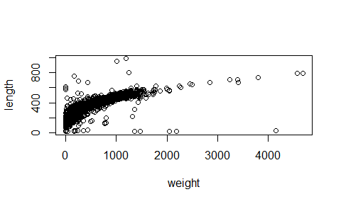

plot(length ~ weight,   
 data = BlackfootFish_clean,   
 xlab = "Weight (gm)", ## adding in axis labels  
 ylab = "Length (cm)",   
 las = 1, ## changing orientation of y-axis labels,  
 main = "Plot of Length by Weight of ..." ## adds a title  
 )

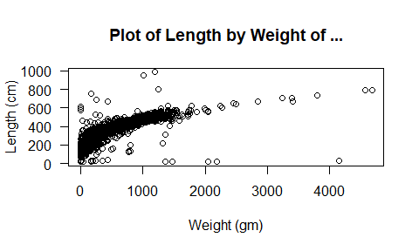

### Distribution

A histogram shows how many observations fall into a given range of values of a variable and can be used to visualize the distribution of a single quantitative variable.

hist(BlackfootFish_clean$length)

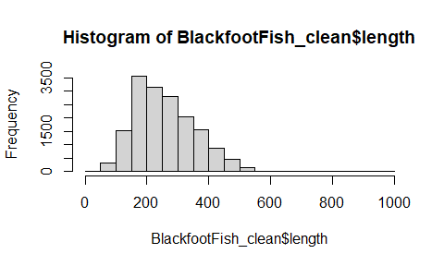

hist(BlackfootFish_clean$length,   
 freq = F) ## converts to a density plot (area adds to 1)

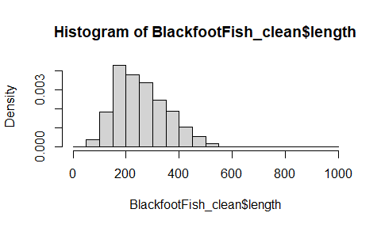

## Does freq need to be named?  
hist(BlackfootFish_clean$length, breaks=8)

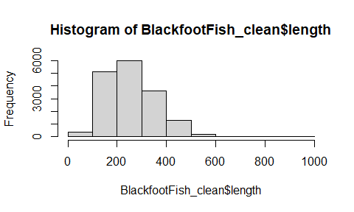

## Why is there an error about the "number of breaks"?

hist(BlackfootFish_clean$length,   
 freq = F,   
 xlab = "Length", ## adds x-axis label   
 main = "Fish Lengths in Blackfoot River" ## adds title to plot  
 )

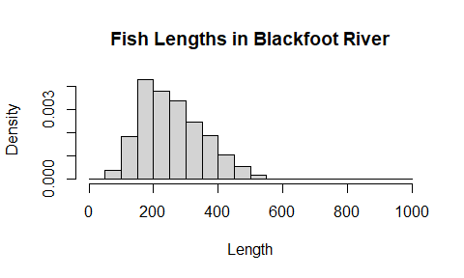

hist(BlackfootFish_clean$length,   
 freq = F,   
 nclass = 50, ## changes the number of bins   
 xlab = "Length",   
 main = "Fish Lengths in the Blackfoot River",   
 las = 1 ## changes orientation of axis labels  
 )

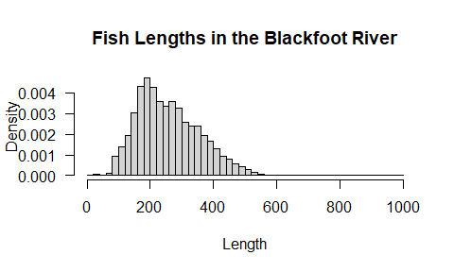

### Side-by-Side Boxplots

The familiar boxplot is a simple display to use when the objective is to compare the distribution of a quantitative variable across different levels of a categorical variable.

## What other options are available to add to your boxplot?  
boxplot(weight ~ species,   
 data = BlackfootFish_clean)

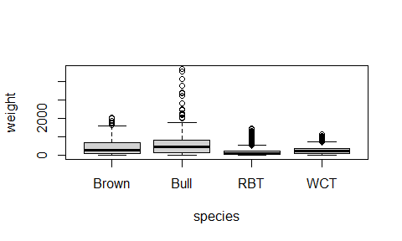

### Bar Charts

Bar charts are an effective way to compare the frequencies of levels of a categorical variable.

section <- table(BlackfootFish_clean$section)  
## tables the number of fish that were caught in each section  
  
barplot(section,   
 xlab = "Section", ## adds axis labels to plot   
 ylab = "Number of Fish",   
 main = "Fish Caught by Section", ## adds title to plot  
 las = 1, ## changes orientation of axis labels  
 col = "blue", ## specifies what color the bars should be  
 ylim = c(0, 12000) ## specifies what range of y-values to plot  
 )

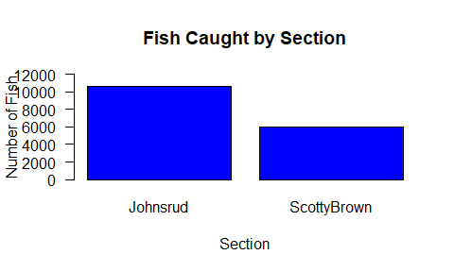

### Practice

**Exercise 11:** Using statistics or graphics, which year in our dataset had the most fish caught?

**Exercise 12:** Make a boxplot of the fish weights over the different years in the dataset.

## Knitting/compiling

Hopefully at this point you have fixed all the code errors in the file we initially provided as you learned about the R code and functions. A final (and sometimes intermediate step) is to compile your Rmarkdown file into an HTML, Word, or PDF document. The compiling process will verify that the code you wrote works in the order that it is present in the document and is your reproducible result to share with colleagues and collaborators. The .Rmd is your archive of the code used to produce those results from the data.

The HTML format is the least nice for printing but also has the fewest dependencies on other software to compile. Compiling to Word requires a word processing software like Microsoft Word. Compiling to PDF either requires the tinytex package in R or a separate installation of miktex, so often requires additional steps beyond what we want to discuss today.

To attempt to knit to one of these formats, go to “Knit” and click on the triangle to select the “Knit to …” version. The entire suite of code will be re-run from beginning to end and, if it works, compiled into the document type you specified.

## Exiting RStudio

Finally, when you are done with your work and attempt to exit out of RStudio, it will ask you to save your workspace. **DO NOT DO THIS!** It will just create a cluttered workspace and could even cause you to get incorrect results. In fact, you should go into the Tools -> Global Options and then make sure that “Save workspace to .RData on exit” option on the first screen you will see is set to Never. If you save your R code either as a .R or (better) an R Markdown (.Rmd) file, you can re-create any results by simply re-running that code or re-knitting the file. If you find that you have lots of “stuff” in your workspace because you accidentally saved your workspace, just run rm(list = ls()). It will delete all the data sets from your workspace.

## Projects in R

R projects provide a way to organize all the code and data in one place and many consider these the best way to work in R. We chose to avoid this step and just use a single .Rmd file to expedite your first experience using R. A motivation for using projects is that it is important to organize your data and script files into the same or related locations and have different locations for different iterations of projects. If you don’t do this:

* it is really hard to tell which version of your data is original and what versions are modified
* things get really messy because all types of files are mixed together
* it’s probably hard for you to find things and relate the correct files to their respective output

Ultimately, good project organization will make your life easier! It helps ensure the integrity of your data, makes it simpler to share your code or get help with your code, allows for you know exactly what code you used on a paper, and it’s easier to pick a project back up.

It is good code writing and file storage practice to keep a set of all related data, analysis, plots, documents, etc. in the same folder. RStudio makes this process easy with using their projects. In an RStudio project, all of the project’s pieces are in the same folder. This allows for a clean workflow and a simple working directory for R. When you are executing code for a document/script R will search for things (such as data) in the folder as the document/script, which is called a *relative path*.

Whenever you start working on a new project in RStudio, go through the following steps:

1. Click on the “File” menu button, then select “New Project”
2. Click “New Directory”
3. Click “New Project”
4. Create a name for your project (make it explanatory!)
5. Select where the project should live
6. Click the “Create Project” button
7. Open the project!

After this process R will be searching for objects (such as data) in the folder as the project. This allows for us to keep all of our files in a self-contained system.

After saving your previous work today, you can try to create a project in a new folder on your computer. After you create the project, you can create a new .Rmd file and copy and paste the text from this document into this file. And move a copy of the BlackfootFish.csv into the project folder you created. Whenever you open this project it will take you directly to the work you have done in that project folder. It may be useful to close the project before exiting RStudio to avoid confusion in later sessions.

## Terminology Used in Workshop

* *Command*: A command is what R executes. In an R script file (script.R), commands are automatically implied, as this type of file does not accept text, only in comments. In an Rmd (Markdown) file (report.Rmd), commands are delineated between three ticks on the top (```{r}) and three ticks (```) on the bottom.
* ```{r}  
  # Your code goes here  
  ```
* *Comment*: Helpful text added into a script environment. Comments can be used to describe functions, processes, a train of thought, so that when you return to your code, tomorrow or next year, you are able to understand the purpose of each line of code! Comments are preceded by at least on # within a code chunk.
* *Object*: A variable created in R, to be used elsewhere in the code. Objects can be a variety of things, such as scalars (x <- 3), vectors (x <- c(1, 2, 3, 4, 5)), matrices, and dataframes, to name a few.
* *Assignment Arrow*: The assignment arrow <- is used to assign values on the right to the objects on the left (x <- 1). For historical reasons, you can also use = for assignments, but not everywhere. Because of these slight differences, it is recommended to *always* use assignment arrows for assignment.
* *Class*: Most R objects have a class attribute, a character vector giving the names of the classes from which the object inherits. Examples of classes are numeric, factor, integer, character, dataframe, matrix, list.
* *Vector*: A vector is a list of entries, all sharing the same class. A vector has only one dimension, so data extraction uses only a single entry in brackets (e.g. x[3]). You can create vectors of characters (c("a", "b", "c")), vectors of numbers (c(1, 2, 3)), to name a few.
* *Matrix*: Similar to what you may have seen in a mathematics class, a matrix is an object with rows and columns, where every entry in the matrix must be a number.
* *List*: A generic vector, which contains other objects. A list can contain a variety of different classes of objects, e.g., characters, vectors, data.frames, matrices, or outputs from a model! A data.frame is a special type of list where the components are vectors and they all have the same length.
* *Dataframe*: A dataframe is a collection of variables. Dataframes share many of the properties of matrices, where you are able to extract elements using bracket ([]) notation, and lists, where you are able to extract columns using $. Dataframes are used as the fundamental data structure by most of R’s statistical modeling software. Note that tibbles have been more recently created as part of the tidyverse and provide a similar but slightly different object where you can store your data.
* *Argument*: Input(s) into a function, so that an output is created. Most functions take named arguments (e.g., data = BlackfootFish) and the order of the arguments is assumed to follow the order found in the function’s help file. When using a named argument in a function, the name comes first, followed by an = sign, then the input.
* *Logical Value*: TRUE and FALSE value(s) that can be used to turn off/on options in functions and plots, and also to manipulate data.

## Workshop Materials & Recordings Available:

* email Sara Mannheimer ([sara.mannheimer@montana.edu](mailto:sara.mannheimer@montana.edu))
* through the MSU Library YouTube channel: <https://www.youtube.com/watch?v=W6E3hpcoUkQ&feature=youtu.be>
* other related information: <http://www.montana.edu/datascience/>

## How to Learn More About R

This material is intended to provide you with an introduction to using R for scientific analyses of data. The best way for you to continue to learn more about R is to use it in your research! This may sound daunting, but writing R scripts is the best way to become familiar with the syntax. This will help you progress through more advanced operations, such as cleaning your data, using statistical methods, or creating graphics.

The best place to start is playing around with the code from today’s workshop. Change parts of the code and see what happens! Better yet, use the code from the workshop to investigate your own data!

## Montana State University R Workshops Team

These materials were adapted from materials generated by the Data Carpentries (<https://datacarpentry.org/>) and were originally developed at MSU by Dr. Allison Theobold. The workshop series is co-organized by the Montana State University Library, Department of Mathematical Sciences, and Statistical Consulting and Research Services (SCRS, <https://www.montana.edu/statisticalconsulting/>). SCRS is supported by Montana INBRE (National Institutes of Health, Institute of General Medical Sciences Grant Number P20GM103474). The workshops for 2021-2022 are supported by Faculty Excellence Grants from MSU’s Center for Faculty Excellence.

Research related to the development of these workshops is to appear in:

* Theobold, A., Hancock, S., & Mannheimer, S.. Data Science Workshops for Data-Intensive Environmental Science Research, *Journal of Statistics Education*.

The workshops for 2021-2022 involve modifications of materials and are licensed CC-BY. Creative Commons License This work is licensed under a [Creative Commons Attribution 4.0 International License](http://creativecommons.org/licenses/by/4.0/).

The workshops for 2021-2022 involve modifications of materials and are being taught by:

### Sara Mannheimer

* Sara Mannheimer is an Associate Professor and Data Librarian at Montana State University, where she helps shape practices and theories for curation, publication, and preservation of data. Her research is rooted in the examination of the social, ethical, and technical issues that arise as we – as a profession and as a society – grapple with the implications of a data-driven world. She is currently working with a library team to build a Dataset Search for institutions, funded by the National Network of Libraries of Medicine, and she is a PhD candidate at Humboldt University of Berlin, studying data stewardship practices for qualitative data reuse and big social data research.

### Greta Linse

* Greta Linse is the Assistant Director of Statistical Consulting and Research Services (<https://www.montana.edu/statisticalconsulting/>) and the Project Manager for the Human Ecology Learning and Problem Solving (HELPS) Lab (<https://helpslab.montana.edu>). Greta has been teaching, documenting and working with statistical software including R and RStudio for over 10 years.

### Mark Greenwood

* Mark Greenwood is a Professor of Statistics in the Department of Mathematical Sciences at Montana State University and Director of Statistical Consulting and Research Services (<https://www.montana.edu/statisticalconsulting/>). His research interests have involved statistical methods and applications in environmental sciences, education, and biological sciences. Recent work has involved researching diagnostic methods for Multiple Sclerosis. His current research grants include funding from the Mountain West IDeA Clinical and Translational Research - Infrastructure Network (National Institute of General Medical Sciences Grant 5U54GM104944-08) and a grant from the National Multiple Sclerosis Society (RG-1907-34348).